Developer Environment Setup

## Create git repo

Follow repo init instructions (note http only works with public repos, https auth was disable 2021)

# Install git (git for windows includes git bash)

Windows will need git bash

<https://git-scm.com/downloads>

default options work well  
git bash allows for using linux commands on windows  
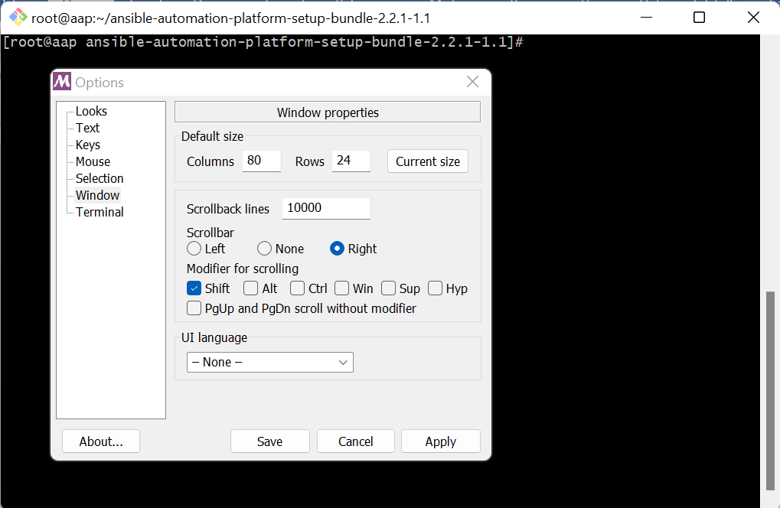

## git ssh-key setup

Decent Guide for installing git and sshkey  
<https://medium.com/devops-with-valentine/2021-how-to-set-up-your-ssh-key-for-github-on-windows-10-afe6e729a3c0>

**After install create ssh key In git bash**  
ssh-keygen -t rsa -b 4096

cat ~/.ssh/id_rsa.pub

**add public key to github**

**(*everyone can add their public ssh keys, also need to add ansible users public key to pull down reposs in tower)**

On github.com go to Settings -> SSH and GPG keys -> new ssh key

# **Set Local git config information in git bash** git config --global user.name "Your Name"

# git config --global user.email “you@example.com” Download/Install Visual Studio Code

<https://code.visualstudio.com/download>

<https://marketplace.visualstudio.com/vscode> (available in app too)  
**after install - things to add -**   
add remote ssh plugin - windows 13m downloads  
add ansible plugin - redhat

add vscode snippets 8.6k DL mattias

add ansible-vault-inline 13k DL wolfmah

Optional Helpful extensions  
markdownlint  
office viewer  
vscode-pdf

*python3.9 to run ansible-core/ansible-lint (requires linux vm/vagrant)  
yum install python39  
ansible-core  
ansible-lint

Using a Test Server for Ansible-Lint, Ansible Code Completion

Log into prod-lnx-3244 as your user

**Install Virtualenv, create venv activate script for vscode**In home directory

python3.9 -m pip install --upgrade pip --user

python3.9 -m pip install virtualenv --user

python3.9 -m venv venv

vim venv.sh #content below

#!/bin/bash

#

source "/$homedir/venv/bin/activate"

#end content **don’t copy this line replace

chmod +x venv.sh  
mkdir git

ssh-keygen -t rsa -b 4096

. ./venv/bin/activate  
pip install ansible-lint  
  
**copy git bash ssh-key to authorized_keys**  
in git bash  
cat ~/.ssh/id_rsa.pub  
on 3244  
vi ~/.ssh/authorized_keys

# **Finish vscode setup**

**Setup Connection to Linux Server**

F1 or CTRL+SHIFT-P - bring down Command Palette  
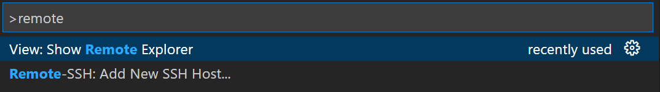

type remote, select Remote-SSH: Add New SSH Host  
  
**Add connection Information**  
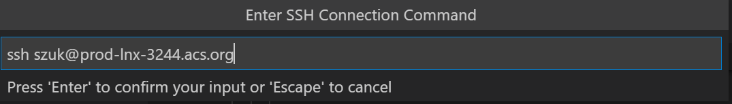  
**Connect to Host**

**Open VSCode Extensions**install ansible extension on remote node  
open setting - select remote node tab - add path to venv.sh /usr01/<user>/venv.sh  
  
Open Folder to WPS or LPS

Additional Items  
  
Docker for Execution Environment (testing) (future item)  
  
Read up on ansible-vscode extension  
<https://www.ansible.com/blog/deep-dive-on-ansible-vscode-extension>

# #Option Configs

Removing Rules from Ansible-Lint - use comma separated list  
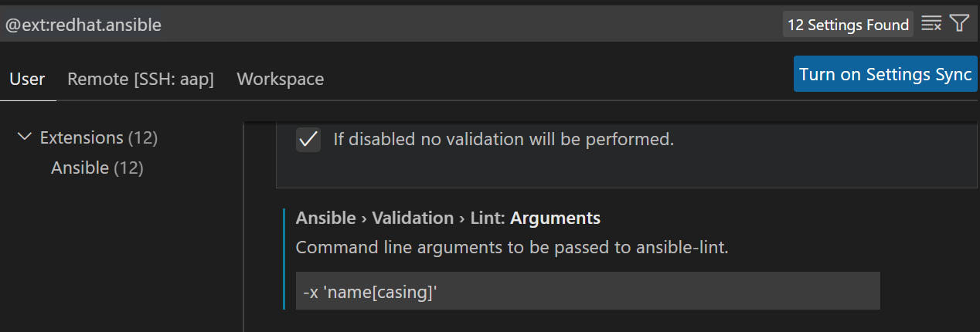

To exclude rules using their identifiers or tags, use the -x SKIP_LIST option. For example, the following runs all of the rules except those with the tags *formatting* and *metadata*:

$ ansible-lint -x formatting,metadata

Git Command Cheat Sheet  
<https://education.github.com/git-cheat-sheet-education.pdf>

Install vagrant & oracle virtualbox for windows (Local Development)  
  
  
<https://developer.hashicorp.com/vagrant/docs/installation>  
*note may take some tweaks for network

<https://www.virtualbox.org/wiki/Downloads>

In git bash  
vagrant init generic/rhel8

vagrant up

vagrant image - generic/rhel8

Create virtualenv  
create ssh-key for vagrant (load into git)  
source venv.sh in vscode on vagrant image  
*#!/bin/bash*

*# Let's call this script venv.sh*

*source "/home/vagrant/venv/bin/activate"*

/home/vagrant  
python3.9 -m pip install virtualenv --user  
python3.9 -m venv venv

. ./venv.sh #activates virtual env  
install ansible-lint and ansible-core  
pip install ansible-lint  
  
mkdir /home/vagrant/git

Troubleshooting –   
  
Remote SSH doesn’t connect Server setup already in progress  
What fixed it was deleting this file (after backing it up):

$HOME/.vscode-server/bin/<long id>/vscode-remote-lock.<username>.<long id>

Tar Bundle Fails to download  
<https://stackoverflow.com/questions/56718453/using-remote-ssh-in-vscode-on-a-target-machine-that-only-allows-inbound-ssh-co>